Car Worth Quiz: Answer a Few Questions to See Your Car’s Value

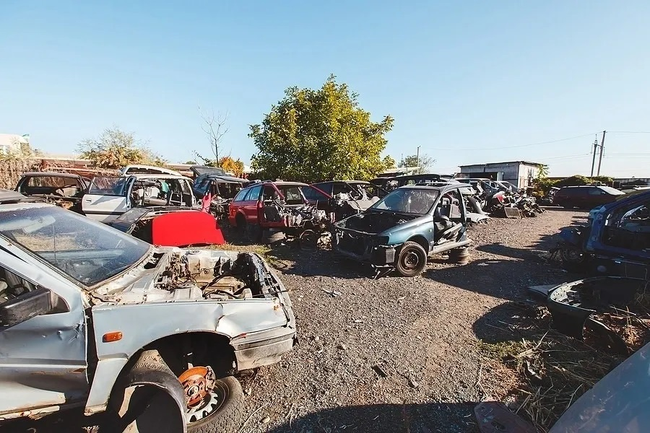

In a fluctuating auto market, deciding the specific worth of your vehicle can feel like a difficult task. Whether you're intending to sell, exchange, or basically need to know your vehicle's ongoing worth, understanding its actual worth is fundamental. An unmistakable, complete vehicle valuation will engage you to settle on informed choices, secure more ideal arrangements, and keep away from likely traps. We should investigate how you can figure out what your vehicle is truly worth today, with techniques that are precise, trusted, and applicable to current [valeur de mon auto](https://scrap-auto.ca/blog/f/valeur-de-mon-auto-comment-%C3%A9valuer-et-optimiser-le-prix-de-reve?blogcategory=Automobiles+et+v%C3%A9hicules) economic situations.

What Decides a Vehicle's Worth? Key Elements in Vehicle Valuation

A vehicle's worth did not depend exclusively on its model or mileage; a few variables can influence the last cost. Realizing these variables can assist you with better comprehension why two comparable vehicles could have radically various valuations. Here are a portion of the vital factors to consider:

1. Age and Mileage

Age and mileage are two of the greatest variables in deciding a vehicle's worth. The more established a vehicle is, the more it for the most part deteriorates. Nonetheless, a high-mileage vehicle that is very much kept up with can some of the time hold more worth than a lower-mileage vehicle that needs legitimate consideration.

Age: A vehicle ordinarily loses around 15-20% of its worth every year. When it is five years of age, a vehicle might have lost around 60% of its underlying worth.

Mileage: High mileage shows more mileage, lessening a vehicle's resale esteem. By and large, vehicles traveled under 12,000 miles each year are thought of "low mileage" and may order higher resale values.

2. Condition

The general state of a vehicle essentially influences its worth. Purchasers and sellers will pay a premium for very much kept up with vehicles that show negligible mileage.

Outside Condition: Search for rust, imprints, and scratches. Vehicles in "like-new" condition get more exorbitant costs.

Inside Condition: Tidiness, upholstery quality, and working elements (like cooling, sound system, and controls) are fundamental.

Mechanical Condition: Motor wellbeing, brake usefulness, and suspension quality are assessed. A vehicle with a legitimate help history by and large has a higher resale esteem.

3. Vehicle History Report

A vehicle history report gives straightforwardness about the vehicle's past, including mishap history, title status, and administration records. Vehicles with clean titles and no significant mishaps are probably going to be esteemed higher.

Mishap History: Vehicles with no mishap history are more alluring, as crashes can prompt underlying and mechanical issues even after fixes.

Title Status: Clean titles are great. Rescue, flood, or modified titles demonstrate harm and can decisively diminish a vehicle's worth.

4. Market Interest and Irregularity

The law of organic market applies to vehicle valuations also. Sought after models, similar to SUVs and trucks, will generally hold higher qualities in numerous locales. Moreover, convertibles might see expanded request (and more exorbitant costs) in hotter months, while all-wheel-drive vehicles might be in more prominent interest during winter.

5. Make, Model, and Trim Level

Some vehicle brands and models are known for their toughness and high resale values, while others devalue rapidly. Higher trims with premium elements (calfskin seats, high level security tech, and so on) for the most part bring more exorbitant costs than fundamental models.

The most effective method to Decide Your Vehicle's Worth: The Best Assets for Exact Valuation

1. Online Vehicle Valuation Devices

One of the least demanding ways of getting a best guess of your vehicle's worth is through internet based vehicle valuation instruments. The following are a couple of confided in choices:

Kelley Blue Book (KBB): Known as quite possibly of the most solid asset, KBB gives values in view of elements like age, mileage, and condition.

Edmunds: Edmunds offers "Genuine Market Worth" (TMV), which depends on deals information and economic situations.

Nothing Guides: Famous with vendors, Nothing Guides gives valuations in view of constant seller deals, adapted to local cost varieties.

These devices utilize broad data sets and calculations to produce gauges, giving you a beginning stage for valuation.

2. Nearby Showroom Evaluations

Visiting a nearby showroom is a compelling method for getting an expert examination. Showrooms frequently lead an intensive review, inspecting the outside and inside condition as well as the mechanical parts of the vehicle. While sellers might esteem your vehicle somewhat lower than private purchasers (because of resale and overall revenues), it's an incredible method for getting a nitty gritty evaluation of your vehicle's worth.

3. Vehicle Purchasing Administrations and Moment Money Offers

Numerous showrooms and online vehicle purchasing administrations offer moment cash offers in light of fundamental data about your vehicle. Sites like Carvana, CarMax, and Vroom permit you to enter your vehicle's subtleties and get a money offer in practically no time. While these offers might be lower than a confidential deal, they are helpful choices in the event that you're searching for a speedy exchange.

4. Confidential Market Examination

For those ready to place in somewhat more examination, checking postings for comparative vehicles in your space on sites like Autotrader, Craigslist, or Facebook Commercial center can be keen. Search for vehicles with comparative age, mileage, and condition to see what cost range they are recorded at.

Expanding Your Vehicle's Worth: Straightforward Tips to Lift Resale Cost

When you know your vehicle's assessed esteem, there are a few stages you can take to expand its allure and possibly increment its worth:

1. Clean and Detail Your Vehicle

A spotless, pleasing vehicle makes areas of strength for an impression. Proficient itemizing costs a piece forthright however can frequently pay for itself in a higher deal cost. A newly cleaned inside, cleaned outside, and motor inlet detail can cause your vehicle look and to feel more current, frequently prompting better offers.

2. Fix Minor Fixes

Handling little fixes like supplanting worn tires, fixing minor scratches, or tending to windshield chips can make your vehicle more appealing to purchasers. A vehicle that shows up very really enjoyed is probably going to order a superior cost, as purchasers will have high expectations about its dependability.

3. Accumulate Documentation

Assuming you've tracked upkeep, fixes, or any overhauls, aggregate these reports. Purchasers love straightforwardness, and an indisputable upkeep history can support your vehicle's worth, as it consoles them of the vehicle's unwavering quality.

4. Think about Selling Secretly

Confidential deals frequently yield greater costs than exchange ins or direct deals to vendors. While a confidential deal requires more exertion, it permits you to haggle straightforwardly with purchasers, which can bring about a value nearer to your vehicle's reasonable worth.

Figuring out Devaluation: How Rapidly Does Your Vehicle Lose Worth?

Deterioration is the rate at which a vehicle loses its worth over the long run. While all vehicles deteriorate, some do so quicker than others. Here is a gander at the typical deterioration rates across different vehicle classes:

New Vehicles: New vehicles lose around 20% of their worth in the main year alone. By the third year, a common vehicle has lost around 40% of its worth.

Extravagance Vehicles: Elegance models frequently devalue quicker than non-extravagance vehicles, as upkeep costs are high, and the market is more specific.

Electric Vehicles: EVs have generally deteriorated rapidly, however as innovation improves and request expands, a few EVs are starting to hold esteem better.

While purchasing a vehicle, taking into account its deterioration rate can assist you with pursuing a monetarily cool headed decision, especially on the off chance that you intend to sell or exchange what's in store.

Selling Choices: Where to Sell Your Vehicle for the Best Return

Whenever you've decided your vehicle's worth, now is the right time to choose where and how to sell. Here are the most widely recognized techniques:

1. Showroom Exchange

An exchange at a showroom is one of the quickest ways of selling a vehicle, particularly on the off chance that you're hoping to buy another one. While exchange offers are ordinarily lower than private deals, they are advantageous and frequently incorporate tax breaks in specific states.

2. Online Vehicle Purchasing Administrations

Locales like Carvana and Vroom have made it simple to sell your vehicle web based, offering a quick money offer subsequent to presenting your vehicle's subtleties. These administrations offer the comfort of home pickup and fast installment yet could result in a somewhat lower offer than private deals.

3. Confidential Deal

Selling secretly ordinarily yields the best yield, as there is no broker. It requires more exertion — making promotions, meeting with purchasers, and arranging a fair cost — however it can bring about a deal that intently mirrors your vehicle's genuine market esteem.

4. Closeout Locales

Selling your vehicle on stages like eBay Engines can prompt cutthroat offering, particularly in the event that you have an uncommon or popular model. Barters give you admittance to a more extensive pool of purchasers, however achievement frequently relies upon the allure of your specific vehicle.

End: Knowing Your Vehicle's Worth Engages You as a Dealer

Figuring out what your vehicle is truly worth is fundamental for settling on sound monetary choices. By utilizing various valuation apparatuses, understanding the variables that impact cost, and doing whatever it takes to work on your vehicle's condition, you can guarantee you get the most ideal return. Whether you're prepared to exchange, sell secretly, or just fulfill your interest, realizing your vehicle's actual worth will give you trust in your following stages.